**Project Report on**

**Air pollution monitoring System**

**Submitted By**

**Asmita Bag     Soumili Ray**

Registration Number.: 203211-11-0036           Registration Number: .: 211-1211-0471-20

Roll Number.: 203211-11-0036 Roll Number: 203211-11-0043

A report submitted in partial fulfilment of the degree of

**B.Sc. (Hons) in Computer Science**

**Supervised by – Mrs. Monali Poddar**



**Department of Computer science**

**Maharaja Manindra Chandra College, University of Calcutta**

# Project Certification

This is to certify that the project entitled **“Air pollution monitoring System”** submitted by

Asmita Bag

University Roll No.: 203211-11-0036

University Reg. No.: 211-1211-0446-20

&

Soumili Ray

University Roll No.: 203211-11-0043

University Reg. No.: 211-1211-0471-20

to the, **Department of Computer Science, Maharaja Manindra Chandra College,,** **University of Calcutta,**towards the partial fulfilment of the degree of **Bachelor of Science in Computer Science**. is a bonafide project work is carried out by them under the supervision of Mrs. Monali Poddar. The contents of this project have not been submitted to any other Institute or University for the award of any degree or diploma.

**Place – Kolkata**

**Name of the supervisor** – **Mrs.** Monali Poddar

**Date –**

**Department of Computer Science**

**University of Calcutta**

# ……………………… .………………………

Project’s Supervisor Signature of HOD

(Department of Computer Science, CU) (Department of Computer Science, CU)

**…………………………….**

External Examiner

Date: …………. Place: ………….

**Acknowledgement**

Firstly, we would like to express our special thanks of gratitude to our Computer Science teacher and mentor in this project Mrs. Monali Poddar for constantly supervising our paper correcting all faults and backlogs. With her support we were able to finish our paper within given time limit.

Next, we would also like to extend our gratitude to the Computer Science Department of Maharaja Manindra Chandra College and our H.O.D. sir, Mr. Biswajit Prasad for supporting and encouraging us for this project. Without such wonderful help and support we would have to face many difficulties.

**Name:** Soumili Ray

**Signature**

**Name:**Asmita Bag

**Signature**

**TABLE OF CONTENT**

**----------------**

**Chapter 1:Abstraction**

**Chapter 2:Introduction**

Domain Description

Objective/Motivation

aim/purpose/scope of Work

Scope of IOT

**Chapter 3:Background of Work**

**Chapter 4:Methodology**

Hardware Description

Components used/requirement specification

Brief description of components

Software Description

User Interface(website)

Working flow-

Diagram

Description

ERD

DFD

User Authentication And Access control

Use Case diagram

Chapter 5: **Algorithm Description**

**Chapter 6: Implementation**

Hardware Implementation

Final Hardware model

Circuit diagram

Software Implementation

Database Implementation

Database Design and Schema

Data Storage and Retrival

Importance and Utilization of stored data

Graph

**Chapter 6:Result and discussion**

Experiments

result and conclusion

Cost estimation

Future Scope

**Chapter 7:References**

Description of software Library used

References

**Abstract**

Air pollution is one of the biggest threats to the present-day environment. Everyone is being affected by air pollution day by day including humans, animals, crops, cities, forests and aquatic ecosystems. Besides that, it should be controlled at a certain level to prevent the increasing rate of global warming. One of the main source of air pollution are industries. This project aims to design an IOT-based air pollution monitoring system using the internet through an website from anywhere using a computer to monitor the emission from industries around us and further ventilation of emission which may prevent accidents in industries and which will send a warning message beforehand in such case. There are various methods and instruments available for the measurement and monitoring quality of air. The IoT-based air pollution monitoring system would not only help us to monitor the air quality but also be able to send alert signals whenever the air quality deteriorates and goes down beyond a certain level.

In this system, Arduino Uno plays the main controlling role to fetch data from different industry. It has been programmed in a manner, such that, it senses the sensory signals from the sensors and shows the quality level via led indicators. Besides the harmful gasses (such as CO2, CO, smoke, methane etc) temperature can be monitored through the temperature and humidity sensor by this system. Sensor responses are fed to the NodeMCU through which the data are stored into database with respect to the industry data which can be utilized for analyzing the gasses quality emitted from a particular industry through an website. If any industry emits large amount of polluted gas then a warning mail will be sent through the website. Secondly temperature sensor is used to avoid any industrial accident by ventilating the poisonous air.

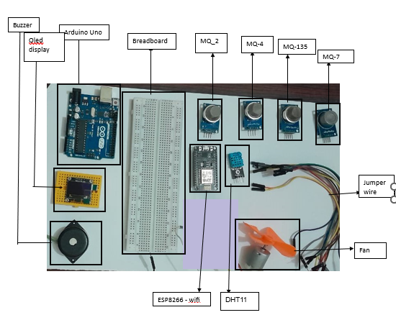

**Introduction**

* **Domain Description:**

The domain in air pollution monitoring systems involves the integration of various technologies and components to collect, analyze, and communicate air quality data. This includes IoT devices such as sensors, data communication networks, data storage and processing systems, and web-based applications.

**IOT domain:**

The IoT domain in air pollution monitoring systems involves the use of sensors and other IoT devices to collect data on air quality parameters such as particulate matter, carbon monoxide, nitrogen oxides, and ozone. This data is then transmitted to a central system where it can be analyzed and used to generate insights and inform decision-making related to air pollution management. The use of IoT technology allows for real-time monitoring of air quality and can help identify areas where pollution levels are high, as well as track changes in air quality over time.

**Web Domain:**

The web domain in air pollution monitoring systems involves the use of web-based applications to display and analyze air quality data collected from various sensors and other IoT devices. The web-based application provides a user-friendly interface that allows users to view real-time air quality data, and other relevant information. The application may also include features such as alerts, notifications, and data visualizations to help users better understand the air quality data. The web domain is an important component of air pollution monitoring systems as it enables easy access to air quality information for stakeholders such as government agencies, researchers, and the public.

* **Motivation:**

The purpose of a smart air pollution monitoring system is to provide real-time information about the quality of the air in a given location. Air pollution is a significant public health concern that can cause respiratory problems, heart disease, and other adverse health effects. Monitoring the air quality can help individuals and communities make informed decisions about their daily activities, such as whether to exercise outdoors, and can also inform policy decisions related to environmental regulation.

A smart air pollution monitoring system can measure a variety of air pollutants, including particulate matter, carbon monoxide, nitrogen dioxide, and ozone, among others. By providing real-time data on the levels of these pollutants, the system can help individuals and organizations understand the sources and extent of air pollution in their area, and take appropriate measures to protect themselves and others.

Overall, the purpose of a smart air pollution monitoring system is to promote public health and well-being by providing accurate, timely information about the quality of the air we breathe.

* **Scope of Work:**
* System Design and Installation:
  + Assessing the monitoring requirements and objectives.
  + Designing a system that meets the specific needs of the monitoring project.
  + Installing monitoring equipment and sensors at the designated sites.
  + Establishing communication infrastructure to transmit data from monitoring stations to a central data management system.
* Data Collection and Measurement:
  + Ensuring the proper functioning of monitoring equipment and sensors.
  + Collecting real-time or periodic air quality data, including various pollutants such as particulate matter (PM), nitrogen dioxide (NO2), sulphur dioxide (SO2), ozone (O3), carbon monoxide (CO), etc.

Monitoring meteorological parameters that can affect air quality, such as temperature, humidity

* Data Management and Analysis:
  + Developing a centralized database or data management system to store and organize the collected data.
  + Implementing data processing techniques to clean, filter, and aggregate the raw data.
  + Analyzing the collected data to identify trends, patterns, and potential sources of pollution.
  + Generating reports and visualizations that present the air quality information in a comprehensible manner.
  + Conducting statistical analysis and modeling to assess the impact of air pollution and evaluate the effectiveness of pollution control measures.
* System Maintenance and Calibration:
  + Conducting regular maintenance and calibration of monitoring equipment and sensors to ensure accurate and reliable measurements.
  + Performing routine checks and troubleshooting to address any technical issues or malfunctions.
* **Scope of IoT**

The scope of the Internet of Things (IoT) in smart air pollution monitoring and smart ventilation systems is significant. By integrating IoT technologies into these systems, it is possible to create more efficient, automated, and data-driven solutions for monitoring and mitigating air pollution levels.

One of the main advantages of using IoT technologies in smart air pollution monitoring systems is the ability to collect and process large amounts of data in real-time. By integrating sensors with IoT devices, it is possible to collect data on air pollution levels, weather conditions, traffic patterns, and other environmental factors that can impact air quality. This data can then be processed and analyzed in real-time, providing insights into the sources of air pollution and helping to develop effective strategies for mitigating their impact.

Similarly, by integrating IoT technologies into smart ventilation systems, it is possible to create more efficient and data-driven solutions for maintaining healthy indoor air quality levels. IoT-enabled ventilation systems can use sensors to monitor indoor air quality levels and adjust ventilation rates accordingly, ensuring that the air quality remains within safe limits.And Also hazardous situations can be avoided.

Moreover, IoT-enabled smart air pollution monitoring and smart ventilation systems can be integrated with mobile applications and cloud-based platforms, allowing users to access real-time air quality informationThis can help individuals make more informed decisions about their health and well-being and contribute to creating healthier and more sustainable communities.

Overall, the scope of IoT in smart air pollution monitoring and smart ventilation systems is significant, and the integration of IoT technologies can play a critical role in promoting sustainable and healthy environments for individuals and communities.

## **Background related work**

**Review related projects:**

## **Methodology**

## **Problem Formulation:**

A monitoring system refers to a set of tools, software, and processes designed to observe, track, and analyze various aspects of a system, network, or environment. It is used to ensure the proper functioning, performance, and security of the monitored entity.

Air pollution refers to the presence of harmful substances in the Earth's atmosphere, which can have adverse effects on human health, the environment, and the overall quality of life. It is primarily caused by human activities and natural processes that release pollutants into the air. So levels opf pollutant in air should be checked,analyzed electronically to facilitate the implementation of measures to improve air quality and protect public health.

An air pollution monitoring system refers to a set of tools, devices, and processes designed to continuously measure, track, and analyze the levels of pollutants present in the air. It utilizes sensors, instruments, and data collection methods to gather real-time or periodic data on various air pollutants, such as particulate matter, nitrogen oxides, sulfur dioxide, carbon monoxide, and volatile organic compounds. The system provides valuable information to assess air quality, identify pollution sources, and support decision-making for pollution control and mitigation strategies..

**WHAT IS AN AIR POLLUTION MONITORING SYSTEM?**

An air pollution monitoring system is a set of instruments and techniques used to measure and analyze the quality of air in a specific location or region. This system can include devices such as sensors, samplers, and analyzers that detect and quantify pollutants in the air. The data collected by the monitoring system can be used to identify sources of pollution, assess the health risks to humans and ecosystems, and inform policies and regulations aimed at reducing air pollution.

## **Advantages of AN AIR POLLUTION MONITORING SYSTEM:**

## 

* Firstly, air pollution poses a significant risk to human health, and exposure to harmful air pollutants can cause respiratory and cardiovascular diseases, cancer, and other health problems. By monitoring air quality levels in real-time, individuals and organizations can take proactive measures to reduce their exposure to harmful pollutants and protect their health.
* Secondly, smart air pollution monitoring systems provide accurate and reliable data that can be used to identify and mitigate the sources of air pollution. By analyzing the data collected by the system, policymakers and regulators can develop effective policies and regulations to reduce air pollution levels and improve overall air quality.
* Thirdly, smart ventilation systems can play a critical role in maintaining healthy indoor air quality levels. Poor ventilation in buildings can lead to the buildup of indoor air pollutants, which can cause health problems. Smart ventilation systems use sensors to monitor indoor air quality levels and adjust the ventilation rates accordingly, ensuring that the air quality remains within safe limits.And also keep safe from sudden hazardous.
* Lastly, the combination of smart air pollution monitoring and smart ventilation systems can help create a more sustainable and healthy environment for individuals and communities. By reducing exposure to harmful air pollutants and improving overall air quality levels, we can protect our health and the environment and promote a more sustainable future.

## **Features of AN AIR POLLUTION MONITORING SYSTEM:**

**1.** **Sensor Technology**: The system incorporates specialized sensors capable of detecting and measuring various air pollutants, including particulate matter (PM), gases (such as nitrogen dioxide, sulfur dioxide, carbon monoxide), volatile organic compounds (VOCs), and ozone. These sensors provide accurate and real-time data on pollutant concentrations.

**2. Data Collection and Transmission**: The system collects data from the sensors deployed in different locations. It uses data logging mechanisms and communication protocols to transmit the collected data to a central database or server for further analysis and storage. This enables real-time monitoring and remote access to the air quality information.

**3**. **Network of Monitoring Stations**: An air pollution monitoring system consists of a network of monitoring stations strategically located across an area or region to ensure comprehensive coverage. These stations are equipped with the necessary sensors, data loggers, and communication infrastructure to collect and transmit air quality data.

**4.** **Real-time Monitoring and Alerts**: The system provides real-time monitoring of air pollutant levels, enabling prompt identification and response to sudden changes or exceedances of air quality thresholds. It can generate alerts or notifications to relevant stakeholders, such as environmental agencies, public health authorities, and the general public, to take appropriate actions when pollution levels are high.

**5.** **Data Analysis and Visualization**: The system includes tools and software for analyzing and visualizing the collected air quality data. It enables users to generate reports, charts, and graphs that provide insights into pollution trends, spatial distribution, and correlations with other factors like weather conditions. Visual representations facilitate easy interpretation of complex data.

**6**. **Historical Data Storage and Trend Analysis**: The system maintains a historical database of air quality data, allowing for long-term trend analysis and retrospective assessments. This helps in identifying pollution patterns, evaluating the effectiveness of pollution control measures, and informing future decision-making processes.

**7**. **Integration with Environmental Models** and Forecasting: Some advanced air pollution monitoring systems can integrate with environmental models and forecasting tools. This integration enables predictive analysis and the generation of air quality forecasts, helping stakeholders anticipate potential pollution episodes and plan preventive measures.

**8. Public Access and Data Transparency**: Many air pollution monitoring systems provide public access to the collected data through web portals, mobile applications, or public displays. This promotes transparency, raises awareness about air quality issues, and empowers individuals to make informed decisions regarding their health and activities.

**9. Compliance Monitoring and Reporting**: The system supports monitoring and reporting compliance with air quality regulations and standards. It generates reports and data summaries that can be used for regulatory purposes, policy evaluation, and decision-making related to pollution control measures.

These features collectively enable effective monitoring, analysis, and management of air pollution, supporting efforts to improve air quality, protect public health, and implement pollution control strategies.

**Key Functionalities of AN AIR POLLUTION MONITORING SYSTEM**

**IOT domain:**

1) Data collection via sensors

2)      Send it to the server

3)      Store the data in databases

4) Check temperature

5) Ringing warning bell when temperature is high and sending warning message

6) Activation of Ventilation System

**Web domain:**

1)      User Sign Up/ Login

2)      Admin Sign Up/Login

3)      Data Analysis

4)      Report checking

5)      Warning Users

6)    Account creation of new user

7) User Profile:

a)      Details Of User

b)      Details of daily record in tabular form

c)      Details of daily record in graphical form

d)      Details of weekly record in tabular form

e)      Details of weekly record in graphical form

f)       Password change

8)  Admin panel:

a)      Verifying New members

b)      Data checking of all registered factories in tabular form(daily and weekly)

c)      Data checking of all registered factories in graphical form(daily and weekly)

d)      Details checking of factories at warning list

e)      Sending Warning mail

## **Design Description**

**Working Flow**

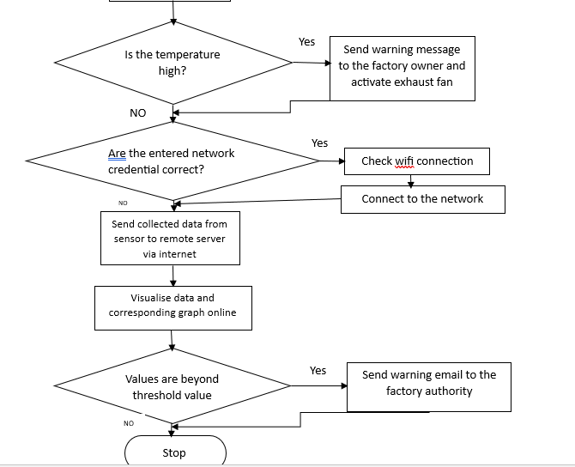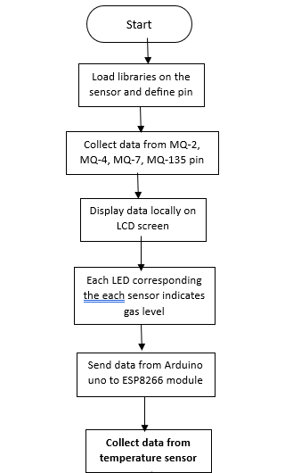

**Entity Relationship Diagram:-**

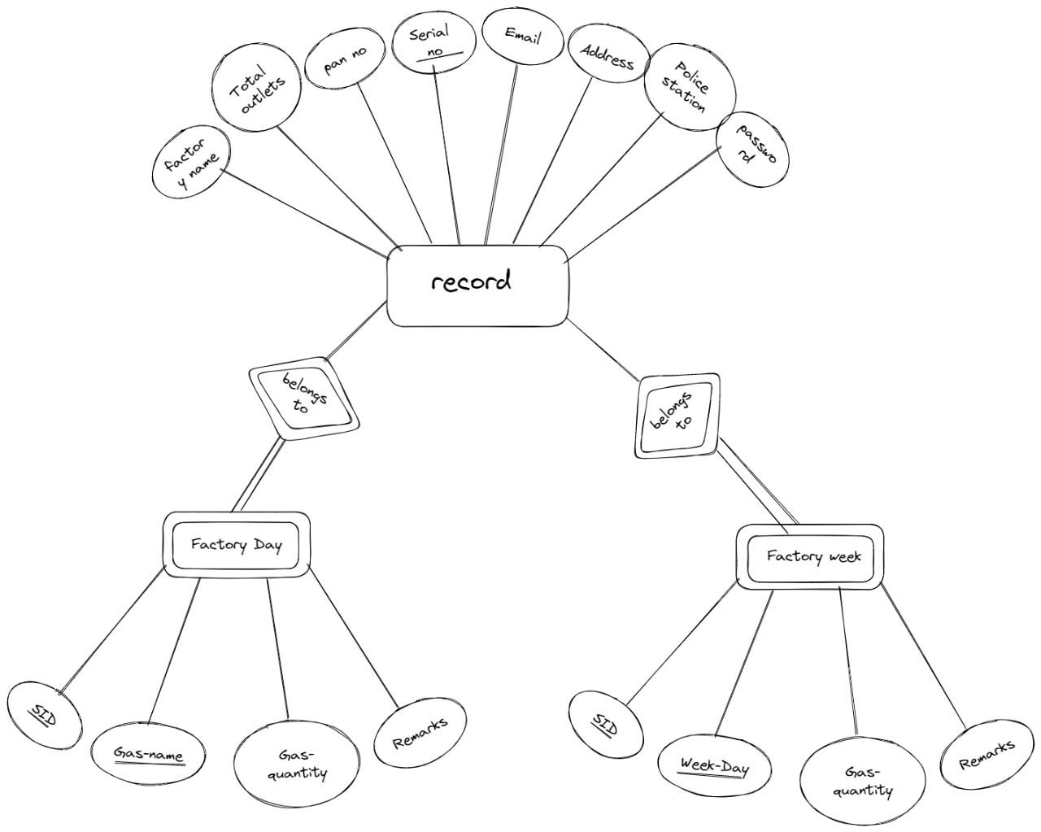

**Data Flow Diagram:-**

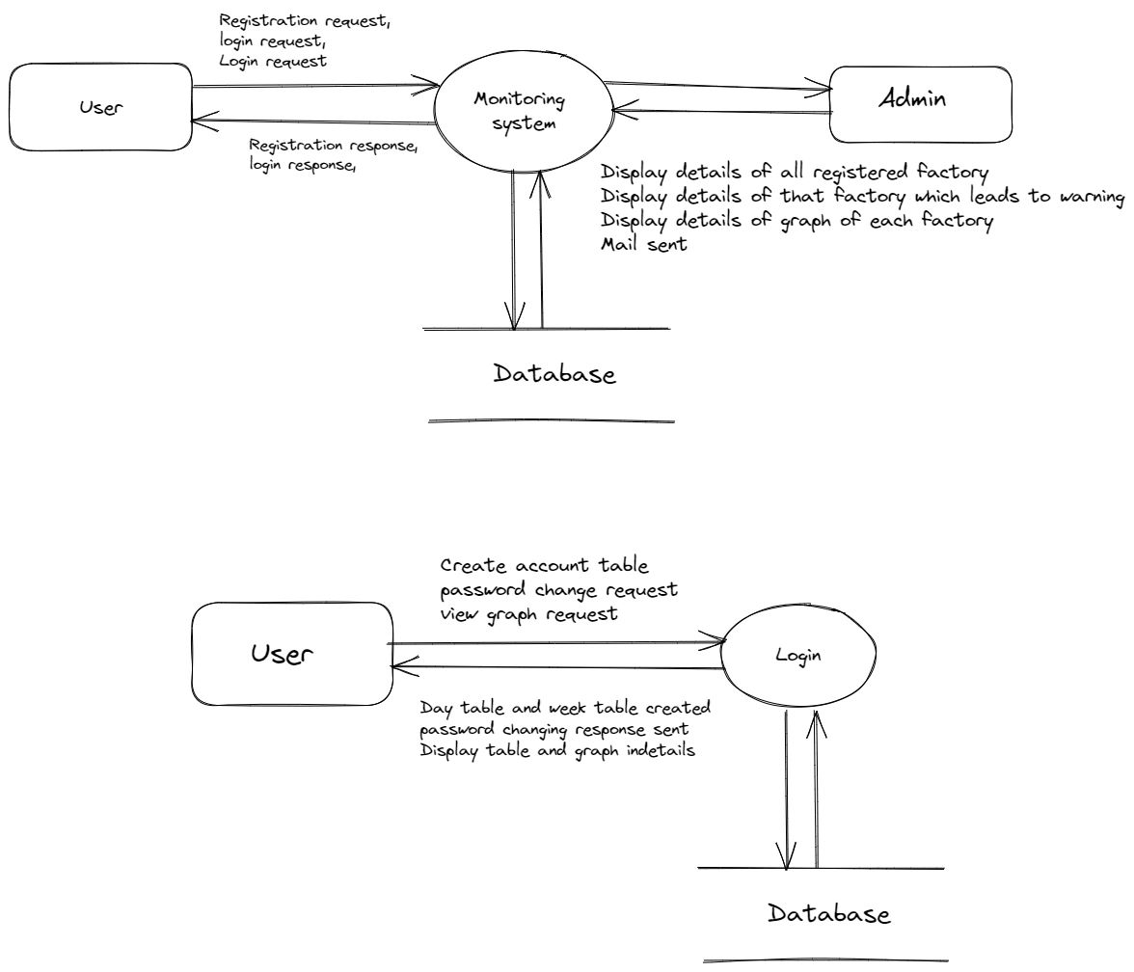

User:-

Level 0

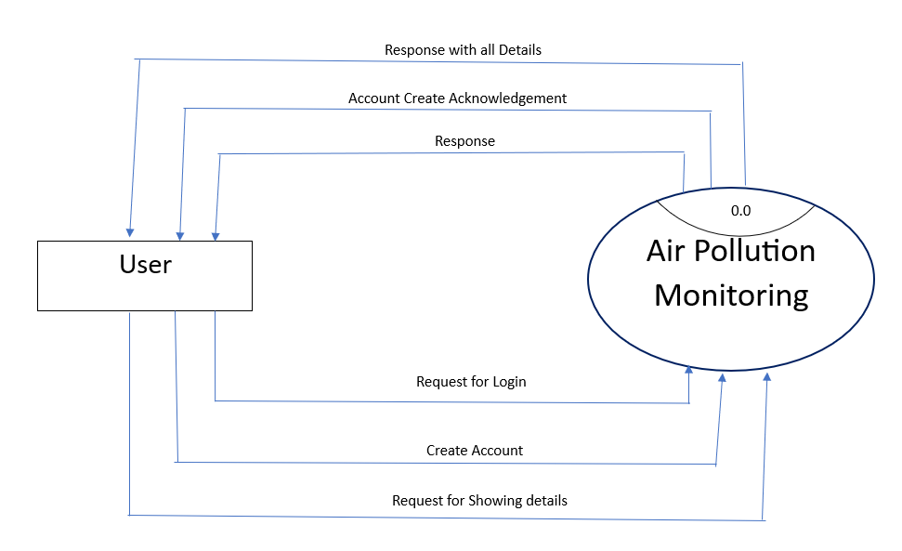

Level 1:

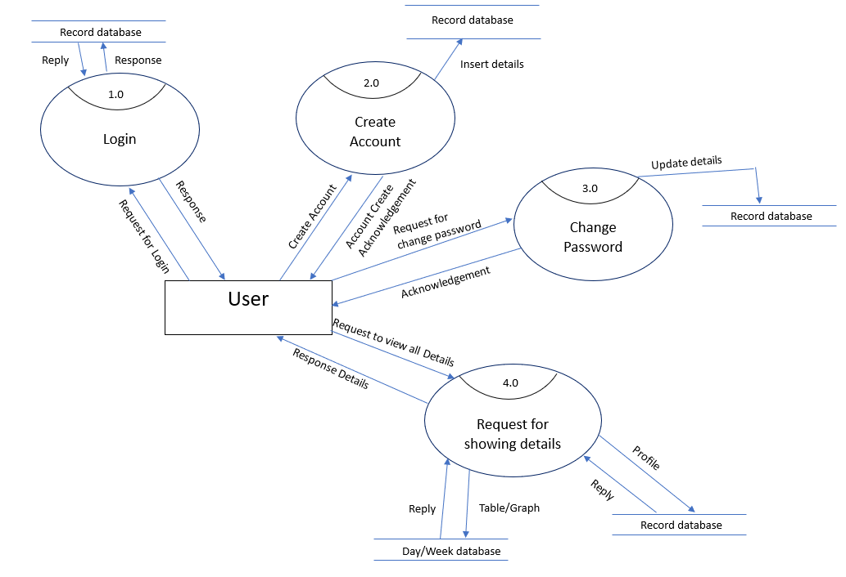

Admin:-

Level 0:

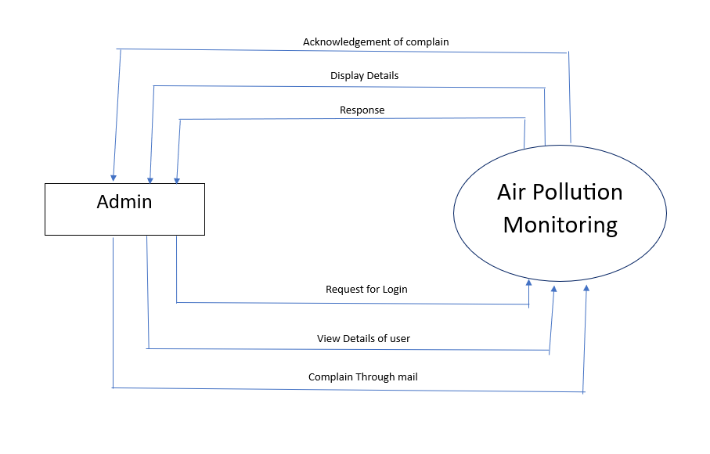

Level 1:

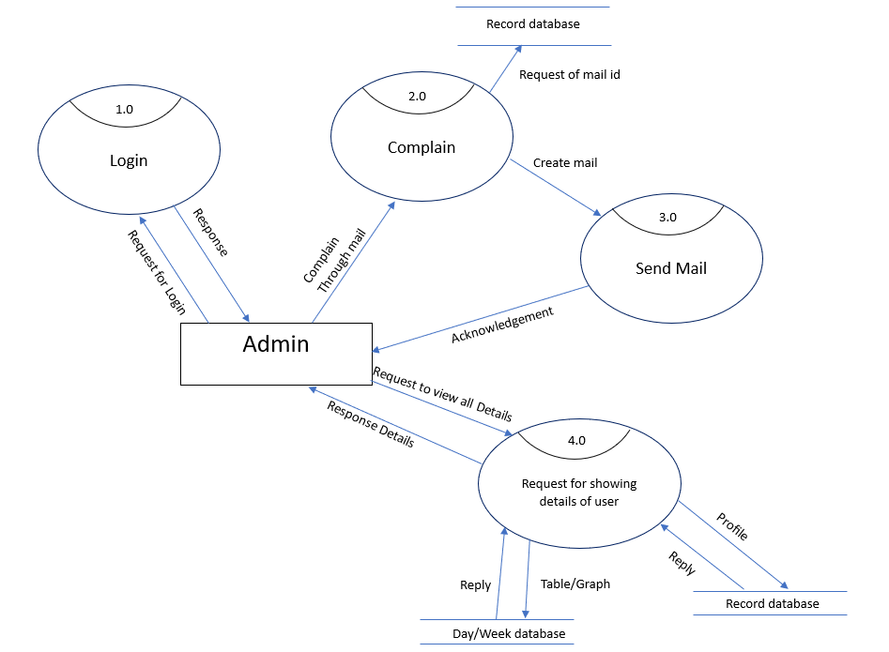

**IOT Module:**

The library in the Arduino was loaded and a message was sent to the LED. Air quality data was collected using the MQ135,MQ-2,Mq-4,Mq-7 sensors. The calibrated sensor made the analog output voltage proportional to the concentration of polluting gasses in Parts per Million (ppm). The data is first displayed on the LCD screen and then sent to the ESP8266 Wi-Fi module. The Wi-Fi module transfers the measured data value to the server via the internet. The Wi-Fi module is configured to transfer measured data On the database of the factory at the website.

Moreover there is a ventilation System , along with sensors temperature is being read through DHT11 sensor .Whenever it becomes more high than usual temperature which indicates fire a warning message will be sent to the Authority of the factory through “Twillow” Api and for emergency ventilation an exhaust fan will get activated and a warning bell will rang from buzzer.

**User Authentication and Access control:**

To ensure data security and restrict unauthorized access, implement user authentication and access control mechanisms. Consider the following:

**User Registration:** Provide a registration form for users to create an account. Collect necessary information, such as name, email, and password, to establish user credentials. Here we have a tab for entering the FACTORY NAME of the user provided the user is a new one accessing the pollution monitoring system website. It has the other tab where the user is entitled to provide their PASSWORD, PAN NO,GOVT. REGISTERED SERIAL NUMBER,EMAIL,ADDRESS,NEAREST POLICE STATION,TOTAL OUTLETS. Once all the credentials are submitted, the user must go for the account making and table generating system.

**Login System:** Implement a login system where users and admin can enter their credentials to access the system. This ensures that only authenticated users and admin can view and interact with the website.

## **User module**:

After successfully logging in by any user, the login page will redirect to a new page, which is their profile page. User can view their daily and weekly reports in both tabular and graphical form. User can review their details and can change password if necessary

**Admin module**:

After successfully logging in by any admin, the login page will redirect to a new page, which is the dashboard of the air pollution monitoring system website. Here at the left most panel there hacve four options DASHBOARD,COMPANY,TABLE, GRAPH. Here Dashboard section shows all the companies who pollute more. Company section will list out all the companies which leads to theirs details page. Table section gives the access to view data of all factories in tabular form. Graph Section gives the access to view the data of all factories in graphical form.

**Role-Based Access Control:** Assign different roles (e.g., administrator, farmer, researcher) to users and define access privileges based on their roles. Administrators will have full access, while other users may have limited access to specific features or data.

**Use Case Diagram:**

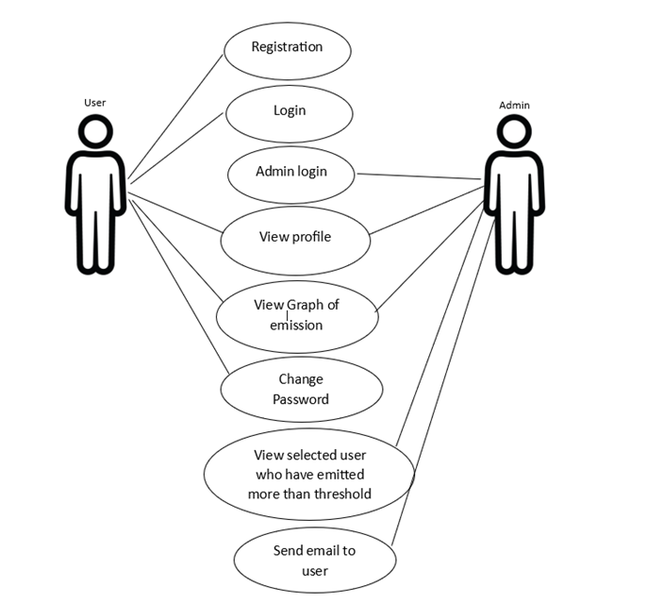

**Database Module:**

The database is an essential component of the Air Pollution Monitoring. It is used to store the collected data, including pollution data. The database enables efficient data management, retrieval, and analysis, providing valuable insights for checking pollution levels.

**Database Design and Schema**

The database design should be based on the specific requirements of the system. The schema typically includes tables to store relevant data fields. A suggested schema for the database could include the following attributes:

Day Table:-

This table will store data in daily basis with respect to four values which is four types of gasses for a particular user. The attributes are as follows-

* Sid: This stores the serial number of a specific company.
* Gasname: Stores the name of the gasses whose emission is to be tracked.
* gasvalue: Stores the value of emission in ppm.
* remarks: Store a remark of ‘warning’ or ‘ok’ if emission value is greater or lesser than a threshold value respectively.

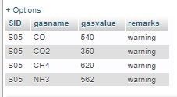

Week Table:-

This table will store data of average emission in a day (store data for a week then new data will be inserted) for a particular user. The attributes are as follows-

* Sid: This stores the serial number of a specific company.
* day: The timestamp of each data entry to track the emission.
* gasvalue: Stores the average value of emission in ppm.
* remarks: Store a remark of ‘warning’ or ‘ok’ if emission value is greater or lesser than a threshold value respectively.

Register:-

The record of each company is stored in this table during registration. The attributes are as follows-

* Fname: Stores the company name.
* toutlets: Stores the Total Outlets of the company.
* pno: Stores the pan number.
* sno: Stores the serial number.
* email: Stores the email id .
* address: Stores the Address of the company.
* ps: Stores the Police Station name near by company.
* psw: Stores the Password generated during registration and use during login.

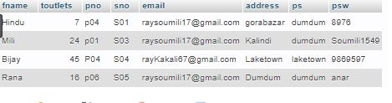

**Data Storage and retrival:**

The data storage and retrieval process involve inserting new data into the database and retrieving stored data for analysis or display. The microcontroller, connected to the database, performs the following steps:

* Data Insertion: The microcontroller, after obtaining gasses emission value readings inserts the data into the Day table in the database and average of four types of gasses emission value in Week Table with respect to the day for a particular company. This process involves establishing a connection with the database and executing an INSERT query to add a new record.
* Data Retrieval: Users can access the stored data for analysis or visualization purposes of it’s own and Admin can access the stored data of all the users. The microcontroller can retrieve data by executing SELECT queries based on user requests or system requirements. The retrieved data can be used to generate reports, graphs, or real-time monitoring on the user interface.

**Importance and utilization of stored data:**

The stored data in the database plays a crucial role in monitoring, analysis, and decision-making processes. Some important aspects of the importance and utlizaton of stored data include:

* Pollution tracking: Here, the stored data into the tables will be used to track the polluting level by an industry .
* Real-time Monitoring: The stored data facilitates real-time monitoring of pollution levels in a week. Users can access the database through the user interface, such as a website, to visualize the current state of emission and make informed decisions.
* Data-Driven Decision Making: The collected data can be used to make data-driven related to the pollution created by the industry and decision making related to send warning email through website.

**Graph:**

The graph is one of the essential part to visual representation of the gasses value (in polluted gas) with respect to day or gasses present in the polluted air emitted by the industry.

**Graph Interface:**

**Day Graph:**

X-axis: represent the name of the gasses.

Y-axis: represent the value of the gasses.

**Week Graph:**

X-axis: represent the day of week.

Y-axis: represent the average value of the gasses.

## **Implementation**

Hardware Implementation:

**Final Hardware setup**

ESP8266 Wi-Fi device is connected with the Arduino; VCC and the CH_EN is connected to

the 3.3V pin of Arduino; TX pin is connected to the RX pin of Arduino; TX pin is connected to

the RXpin of Arduino;

MQ135 ,Mq-2,MQ-4,MQ-5 sensors and corresponding 4 LEDs are connected with the Arduino; VCC pis of sensor connected to the pin 5v of the Arduino; GND pin is connected to the GND of the Arduino; AO pins of MQ135 ,Mq-7,MQ-2,MQ-4 sensors are connected to the A5,A4,A3,A2 pins of the Arduino resp; The LEDs are connected to the 11,9,6,3 pins of the Arduino; LCD is connected with Arduino; VCC & GND pin is connected to the 5 V & GND of the Arduino;SDA pin is connected to the A0 and SLC pin is connected to the A1 pin Arduino.

DHT11 module, a fan and a buzzer are connected to the ESP8266 Wi-Fi module.GND pins of Buzzer and DHT11 are connected to the GND pin of ESP8266 Wi-Fi module.VCC pin of DHT11 pin connected to the 3.3V pin ESP8266 Wi-Fi module. Out pin of DHT11 pin connected to the D3 pin.Buzzer is connected to the D4 pin of the ESP8266 Wi-Fi module. Both pins of Fan motor are connected to the motor controller L298 module ‘s OUT pin. ENA,IN1,IN2 pins of L298 module are connected to the D0,D1,D2 pins of the L298 module. 12V pin and GND pin of L298 module is connected to the exeter power source and GND pin is connected to the GND pin of ESP8266 Wi-Fi module.Another LED pin is connected to the D5 pin of ESP8266 Wi-Fi module.

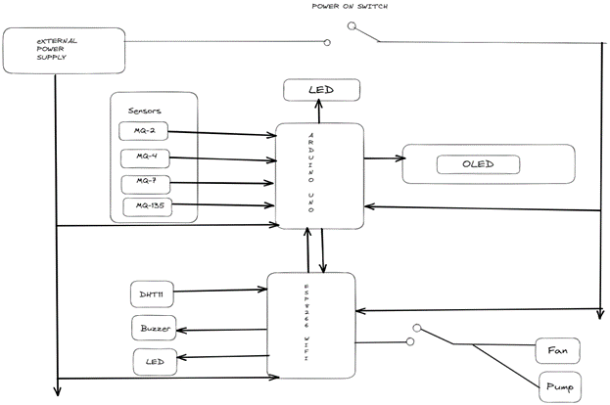

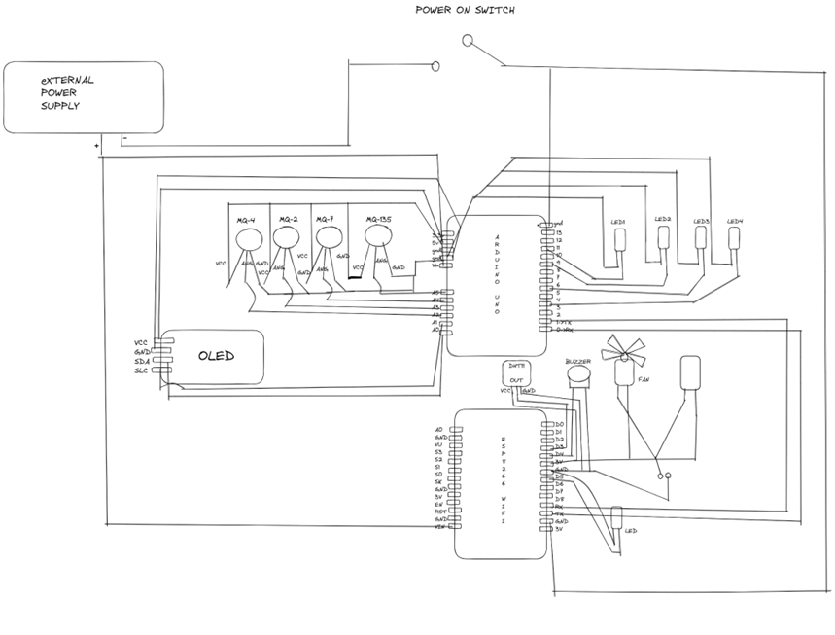

Circuit Diagram

**Software Implementation**

**User Interface(website):**

Here we have prepared a website using html,css (for frontend) and php as scripting language to get the emission values emitted by the industrial companies.

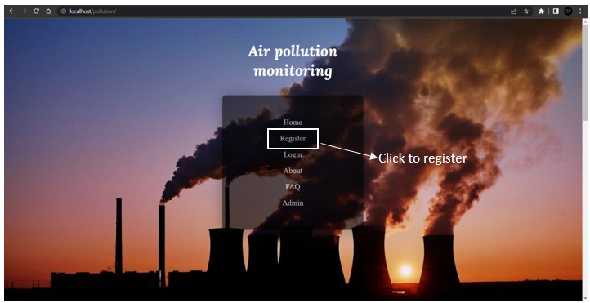

Here first the companies need to register by giving their specific details.

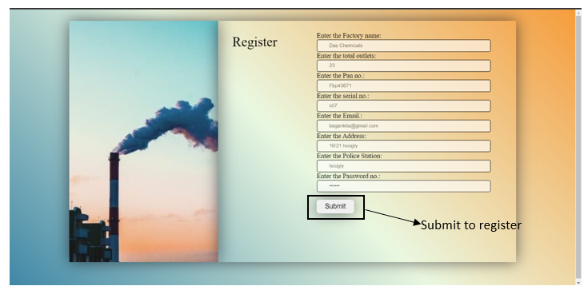

After submitting the register form your data will stored to database under the table record. After registering , you can easily login to your dashboard , where you can see your personal details and emission details as well in both form table and graph.

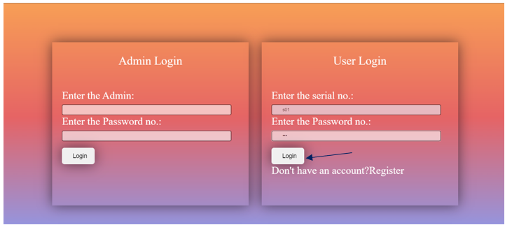

The Dashboard Looks like ➖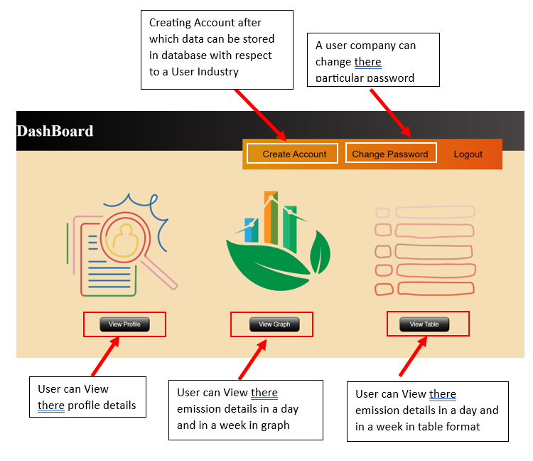

Here, the Admin can look after all the industries emission:-

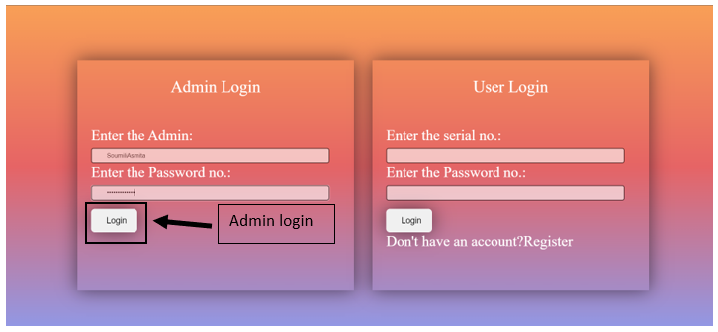

DashBoard of Admin:-

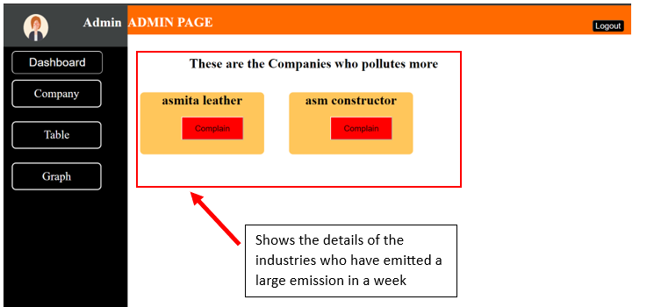

Warning Email Sent via website:-

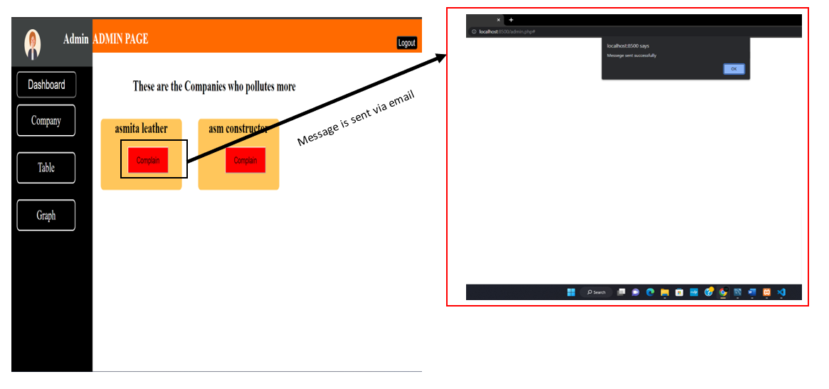

The mail Received by the industries will look like:-



Admin can see all the details of every industry who register themselves:-

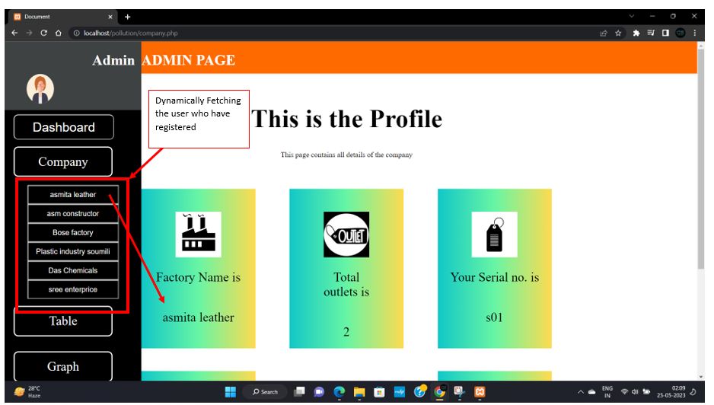

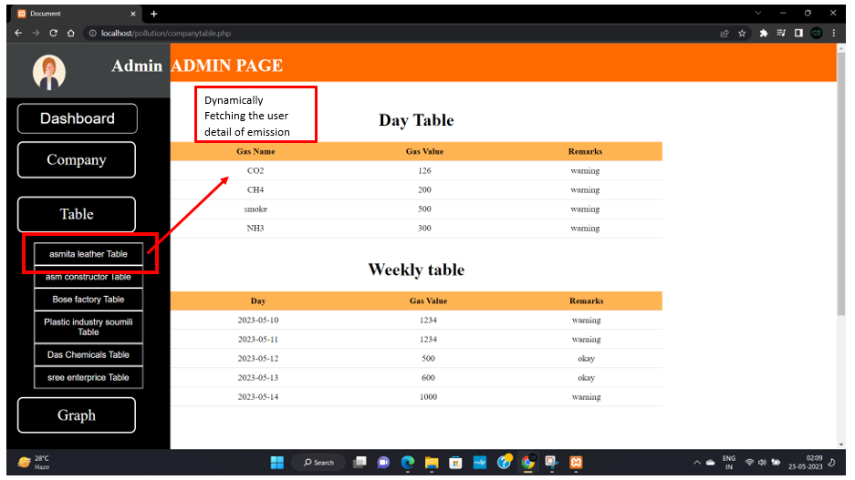

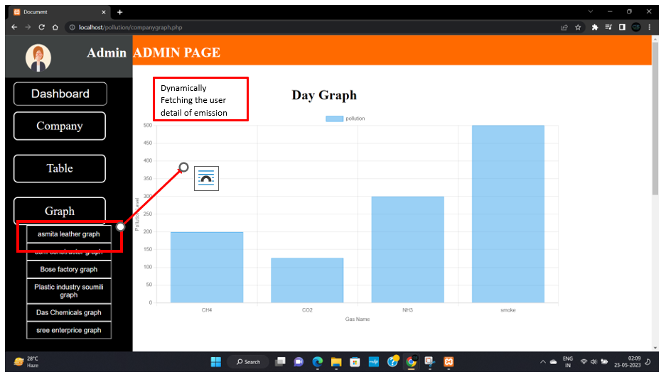

**Chapter 5:**

**Result and discussion**

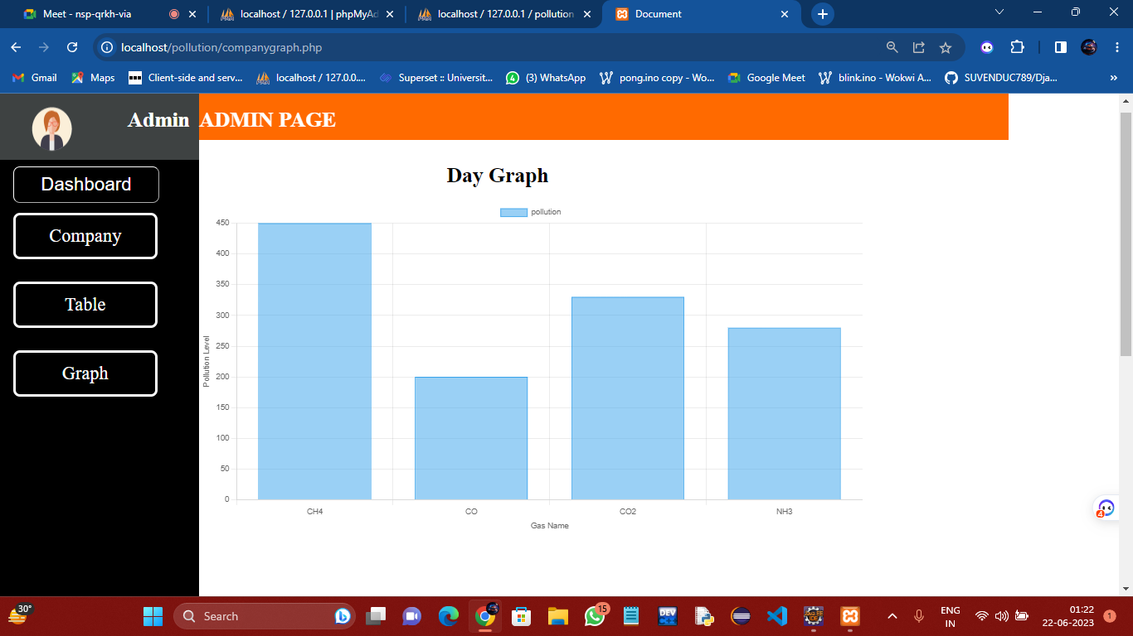

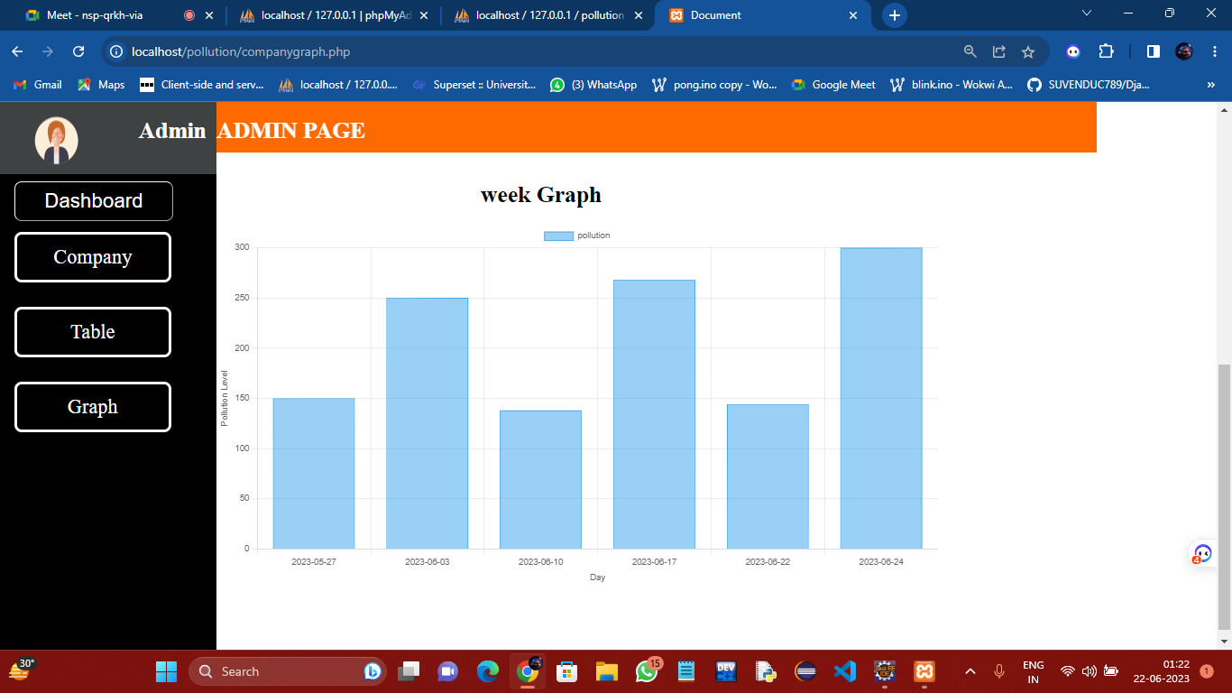

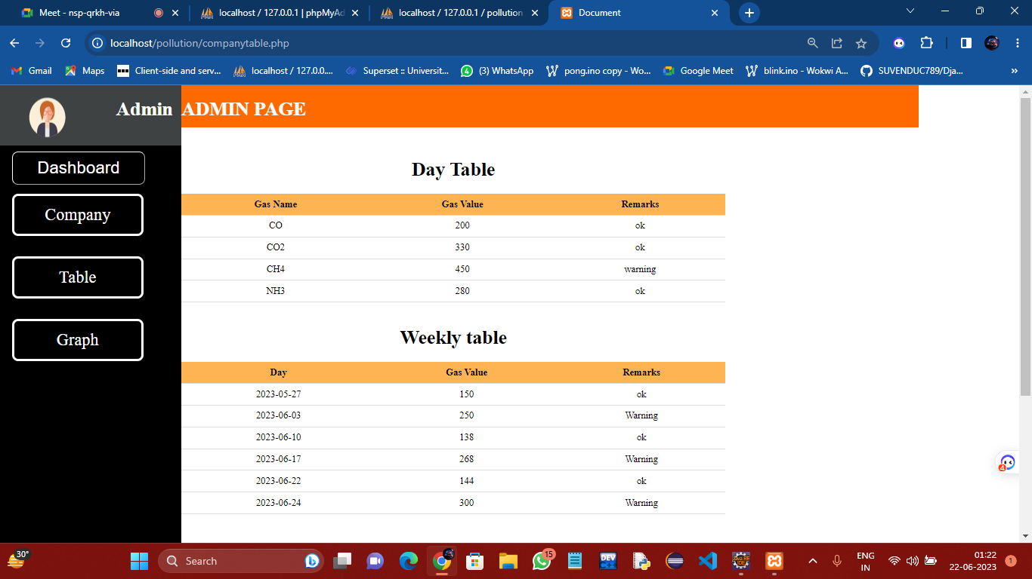

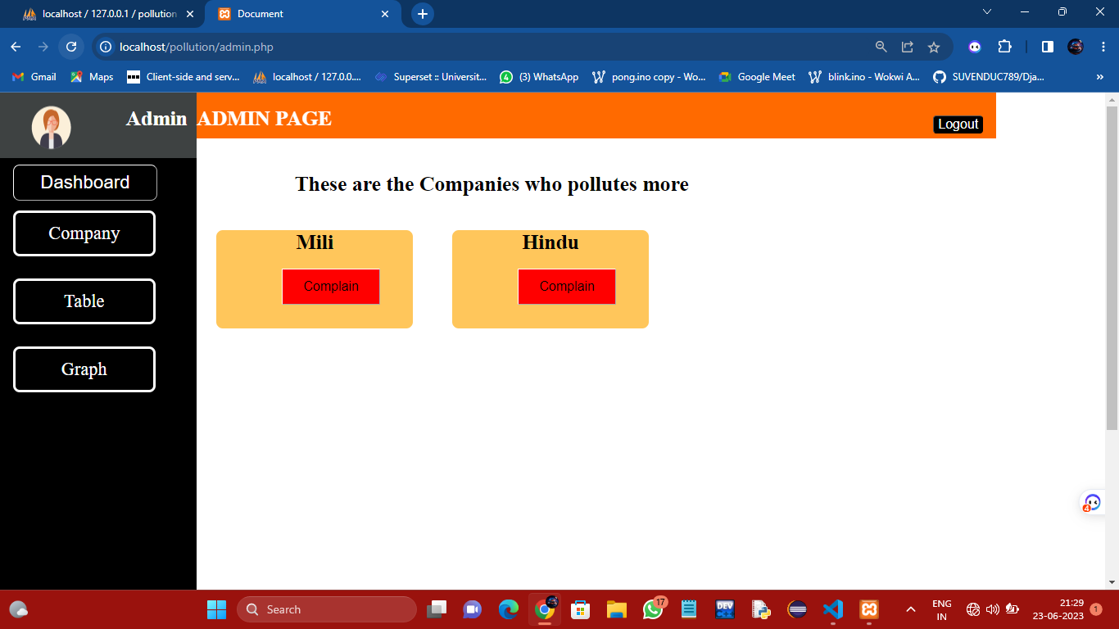

**Experiments**

**Result And Conclusion**

**Cost Estimation**

The cost estimation of a smart air pollution monitoring and smart ventilation system can vary depending on several factors such as the number of sensors, the level of automation, the data processing and storage requirements, and the complexity of the system integration.

Components Price (in Rs)

NodeMCU V3 250

DHT11 Sensor Module 120

MQ135 Gas Sensor Module 210

MQ-2 Gas Sensor Module 210

MQ-4 Gas Sensor Module 210

MQ-7 Gas Sensor Module 210

Connecting Wires 60

LEDs (Red, Green & Yellow) 9

AC-DC Power Adapter 120

L298 motor controller

Buzzer

LCD(16x2) display

Breadboard 70

Total

**Future Scope:**

* The future scope of smart air pollution monitoring and smart ventilation systems is significant, and there are several areas of potential growth and development.
* One area of future growth is the integration of smart air pollution monitoring systems with machine learning and artificial intelligence (AI) algorithms. By analyzing the data collected by the system using advanced machine learning techniques, it is possible to identify patterns and trends in air pollution levels, predict future air pollution levels, and develop more effective strategies for mitigating the sources of air pollution.
* Another area of future growth is the development of smart ventilation systems that use advanced sensing technologies to monitor and control indoor air quality levels. By integrating these systems with smart home automation technologies, it is possible to create more efficient and sustainable buildings that reduce energy consumption and improve indoor air quality.
* Moreover, in complaining section of Admin panel we can add a automated police complain lodging system after a certain times of warning.
* Overall, the future scope of smart air pollution monitoring and smart ventilation systems is promising, and the development of these technologies could play a critical role in promoting sustainable and healthy environments for individuals and communities.